Problem No: 02

Problem Statement:
Implement a checksum-based error detection system for data transmission. The sender accepts a list of integers, computes their sum, converts it to a binary string with padding, and generates a checksum using one's complement. The data and checksum are transmitted to the receiver, which recalculates the sum, adds the checksum using wrap-around binary addition, and verifies integrity by computing the one's complement of the result. If the final value is all zeros, the message is deemed error-free; otherwise, an error is detected.

Algorithm:
1. sum_of_vector(inp)
  - Initialize sum to 0.
  - Iterate through each element in inp, adding it to sum.
  - Return sum.

2.ones_complement(binary)
  - Iterate through each character in binary.
  - Replace '0' with '1' and '1' with '0'.
  - Return the modified binary string.

3. binary_to_decimal(n)
  - Initialize dec_value = 0 and base = 1.
  - Iterate through n from right to left:
  - If the current bit is '1', add base to dec_value.
  - Multiply base by 2.
  - Return dec_value.

4.binary_to_decimal(n)
- Initialize dec_value = 0 and base = 1.
- Iterate through n from right to left:
  - If the current bit is '1', add base to dec_value.
  - Multiply base by 2.
- Return dec_value.

5.add_binary(A, B)
    - Make A the shorter string by swapping if necessary.
    - Pad A with leading zeros to match B's length.
    - Initialize carry = 0 and an empty result string.
    - Iterate from the last index to the first:
    - Compute sum of corresponding bits and carry.
    - Append the sum modulo 2 to the result.
    - Update carry.
    - If carry remains, append '1' to the result.
    - Reverse the result string.
    - Remove leading zeros and return the final binary sum.

6. wrap_sum(a, b)
- Compute sum = add_binary(a, b).
- If sum exceeds WRAP_COUNT bits:
- Extract the last WRAP_COUNT bits.
- Extract the overflow bits.
- Recursively call wrap_sum(last_4, the_rest).
- Return sum.

7. receiver(inp, checksum)
    - Initialize binary to "0000".
    - For each number in inp:
    - Convert it to binary using convert_binary_to_padded_bits().
    - Add it to binary using wrap_sum().
    - Add checksum to binary using wrap_sum().
    - Compute the one's complement of the result.
    - If the final result is all zeros ("0000"), print "Message sent is okay".
    - Otherwise, print "Message sent is not okay".

8. sender(inp)
  - Prompt user to enter the number of elements.
  - Resize inp to the entered size.
  - Read values into inp.

9. main()
  - Call sender(inp) to get input data.
  - Compute sum of inp using sum_of_vector().
  - Convert sum to binary using convert_binary_to_padded_bits().
  - Compute the one's complement of the binary sum.
  - Call receiver(inp, one_s_sum) to validate the checksum.
  - End program execution.

Flowchart:
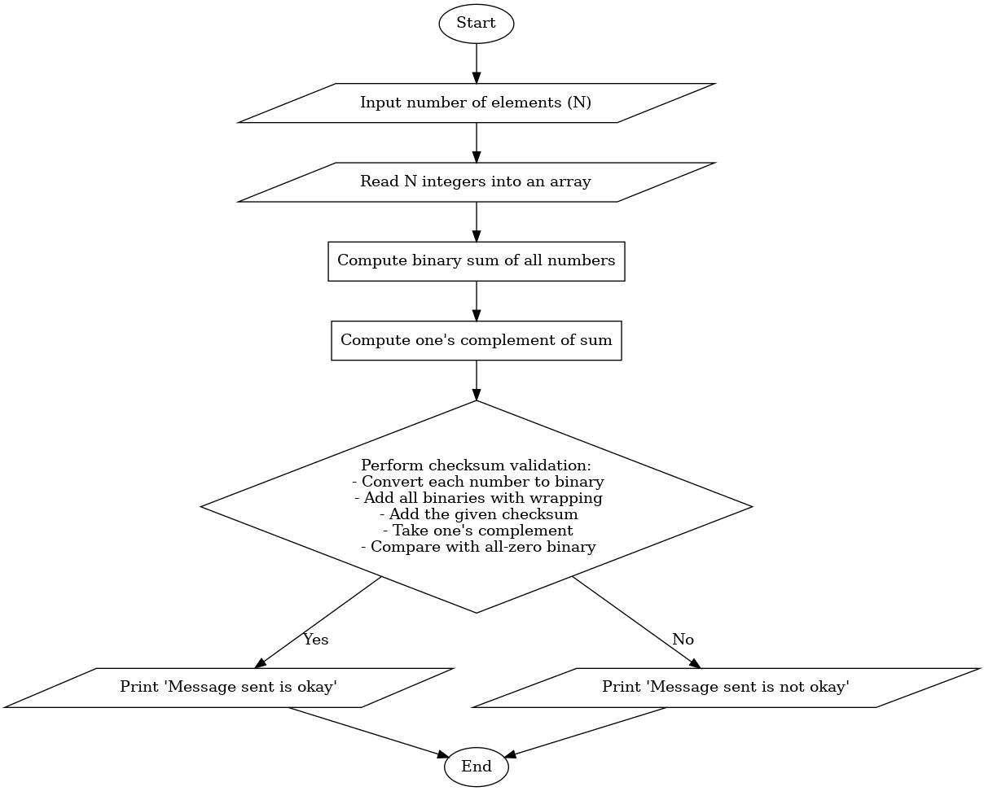

Program:

#include <bits/stdc++.h>
using namespace std;

const int WRAP_COUNT = 4;

long long sum_of_vector(vector<int> inp)
{
long long sum = 0;
for (auto p : inp)
{
sum += p;
}
return sum;
}
string ones_complement(string binary)
{
for (char &bit : binary)
{
bit = (bit == '0') ? '1' : '0';
}
return binary;
}
int binary_to_decimal(string n)
{
string num = n;
int dec_value = 0;

// Initializing base value to 1, i.e 2^0
int base = 1;

int len = num.length();
for (int i = len - 1; i >= 0; i--)
{
if (num[i] == '1')
dec_value += base;
base = base * 2;
}

return dec_value;
}

string dec_to_binary(long long n)
{
if (n == 0)
{
return "0";
}
string bin = "";

while (n > 0)
{
int bit = n % 2;
bin.push_back('0' + bit);
n /= 2;
}

reverse(bin.begin(), bin.end());
return bin;
}

string add_binary(string A, string B)
{
if (A.length() > B.length())
std::swap(A, B);

A.insert(A.begin(), B.length() - A.length(), '0');

string result;
char carry = '0';

for (int i = A.length() - 1; i >= 0; i--)
{
int sum = (A[i] - '0') + (B[i] - '0') + (carry - '0');
result.push_back((sum % 2) + '0');
carry = (sum > 1) ? '1' : '0';
}

if (carry == '1')
result.push_back('1');

reverse(result.begin(), result.end());

long long first_one = result.find_first_not_of('0');
return (first_one == std::string::npos) ? "0" : result.substr(first_one);
}

string wrap_sum(string a, string b)
{
string sum = add_binary(a, b);
if (sum.size() > WRAP_COUNT)
{
string last_4 = sum.substr(sum.size() - WRAP_COUNT);
string the_rest = sum.substr(0, sum.size() - WRAP_COUNT);
return wrap_sum(last_4, the_rest);
}
return sum;
}

void receiver(vector<int> inp)
{
string binary = string(WRAP_COUNT, '0');

for (int i = 0; i < inp.size(); i++)
{
int num = inp[i];
string num_binary = dec_to_binary(num);
binary = wrap_sum(binary, num_binary);
}

string one_s_binary = ones_complement(binary);

bool ok = true;
for (auto p : one_s_binary)
{
if (p != '0')
{
ok = false;
}
}

if (ok)
cout << "Message sent is okay";
else
cout << "Message sent is not okay";
cout << endl;
}
void sender(vector<int> &inp)
{
int i = 0;
cout << "Enter the number of elements:";
cin >> i;
inp.resize(i);
for (int &x : inp)
{
cin >> x;
}
}

int main()
{
vector<int> inp;
sender(inp);

long long sum = sum_of_vector(inp);

string sum_bit = dec_to_binary(sum);
string one_s_sum = ones_complement(sum_bit);

inp.push_back(binary_to_decimal(one_s_sum));

receiver(inp);
return 0;
}

Output:

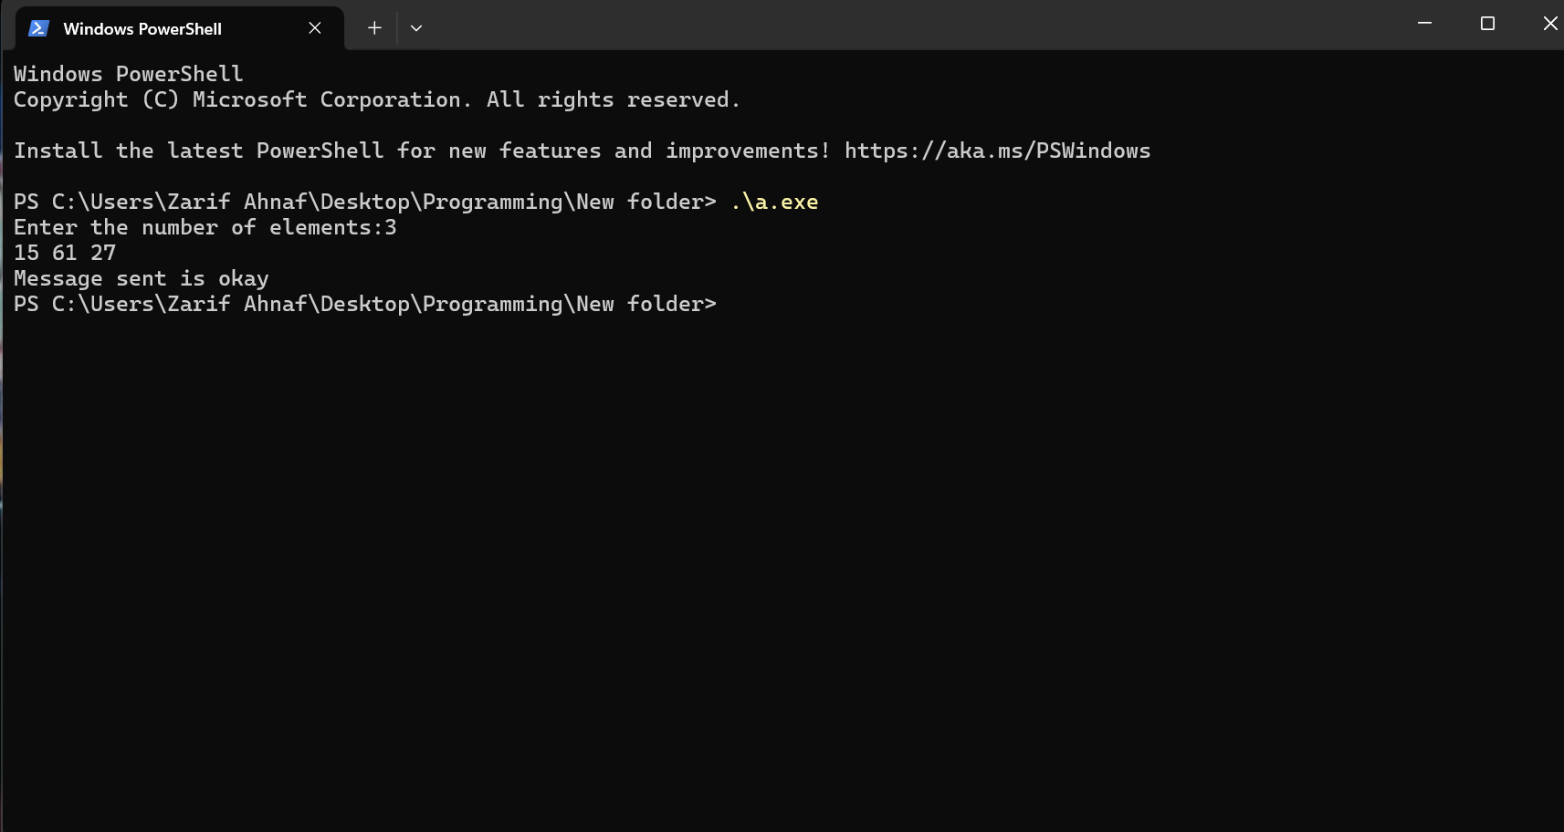

Problem No: 01
Problem Statement:
Implement a basic error detection system using sum verification. The sender accepts a list of integers, calculates their sum, and appends its negation to the list before sending it to the receiver. The receiver recalculates the sum of the received data and verifies if it equals zero. If the sum is zero, the message is considered error-free; otherwise, an error is detected.

Algorithm:

1. sum_of_vector(inp)
- Initialize sum to 0.
- Iterate through each element in inp, adding it to sum.
- Return sum.

2. sender(inp)
- Prompt user to enter the number of elements.
- Resize inp to the entered size.
- Read values into inp.

3. receiver(inp)
- Compute sum = sum_of_vector(inp).
- If sum is 0, print "Message sent is okay".
- Otherwise, print "Message sent is not okay".
- Print a newline.

4. main()
- Declare vector<int> inp.
- Call sender(inp) to get input data.
- Compute sum = sum_of_vector(inp).
- Append -sum to inp.
- Call receiver(inp).

Flowchart:
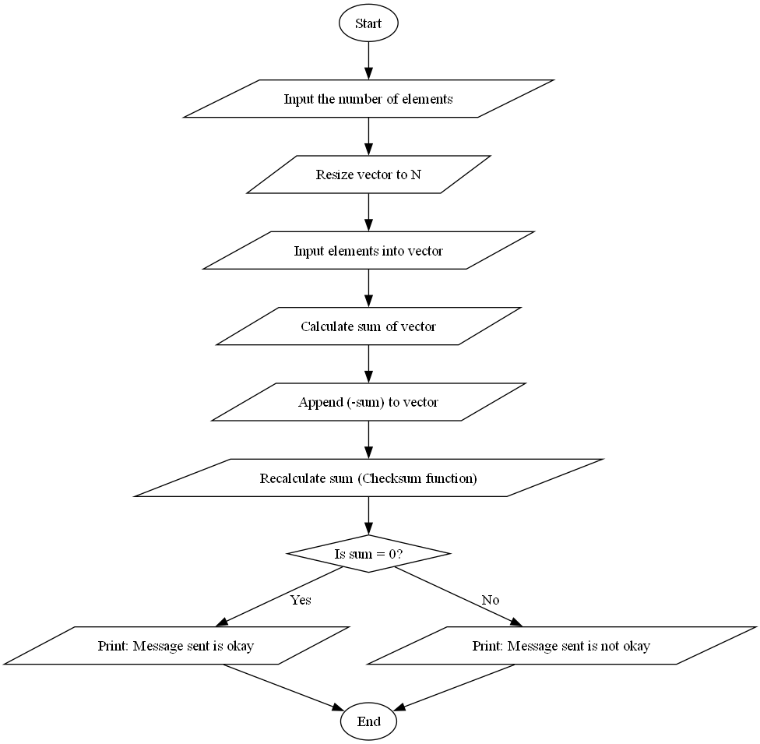

Program:
#include <bits/stdc++.h>
using namespace std;

long long sum_of_vector(vector<int> inp)
{
long long sum = 0;
for (auto p : inp)
{
sum += p;
}
return sum;
}
void checksum(vector<int> inp)
{
long long sum = sum_of_vector(inp);
if (sum == 0)
{
cout << "Message sent is okay";
}
else
{
cout << "Message sent is not okay";
}
cout << endl;
}

int main()
{
vector<int> inp;
int i = 0;
cout << "Enter the number of elements:";
cin >> i;
inp.resize(i);
for (auto &x : inp)
{
cin >> x;
}
long long sum = sum_of_vector(inp);

inp.push_back(-sum);
checksum(inp);
}

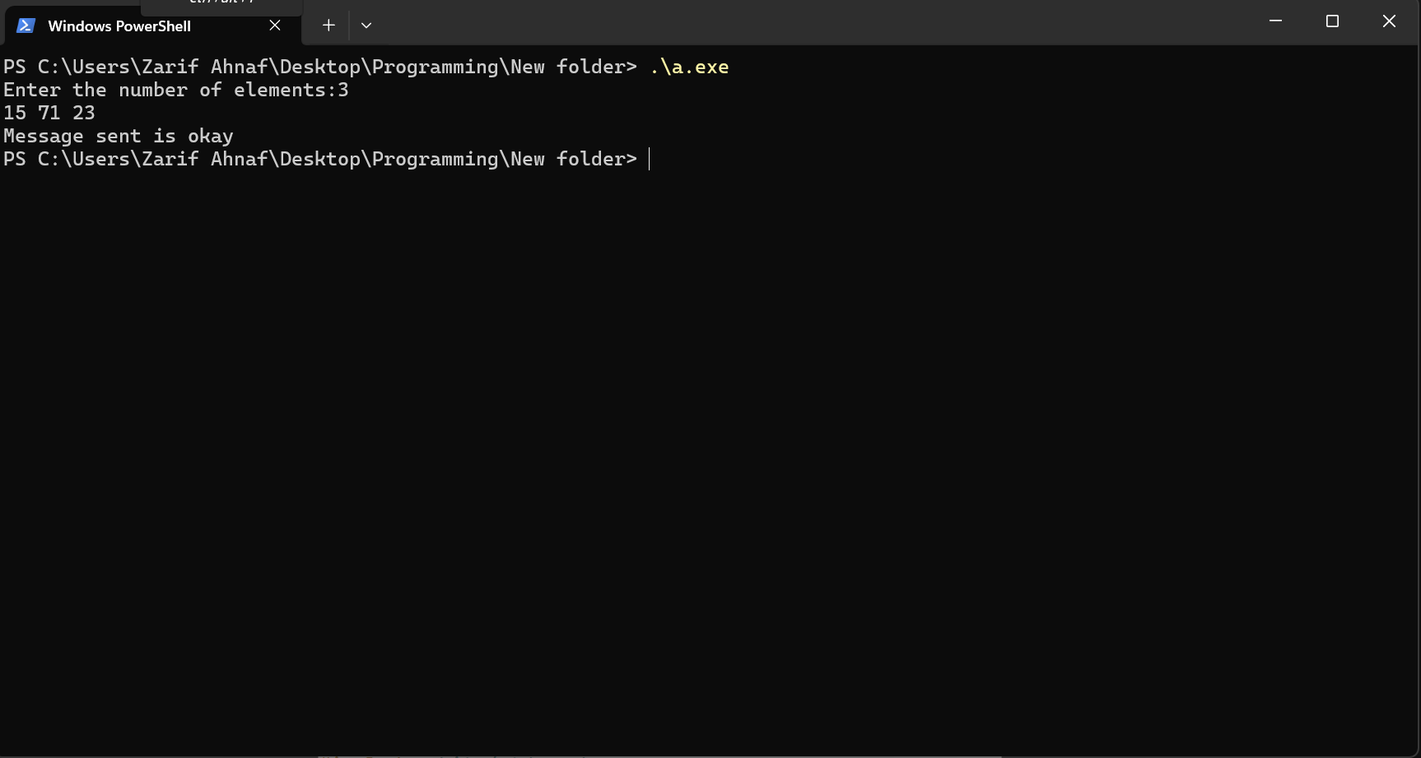
Output:

